Coordinated Entry System Access Guide

To access the CES agency in Clarity, select the drop down arrow underneath your name, next to your agency, located in the upper right hand corner and then select Coordinated Entry System (CES)
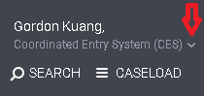
In your client’s dashboard screen select the Programs tab at the top
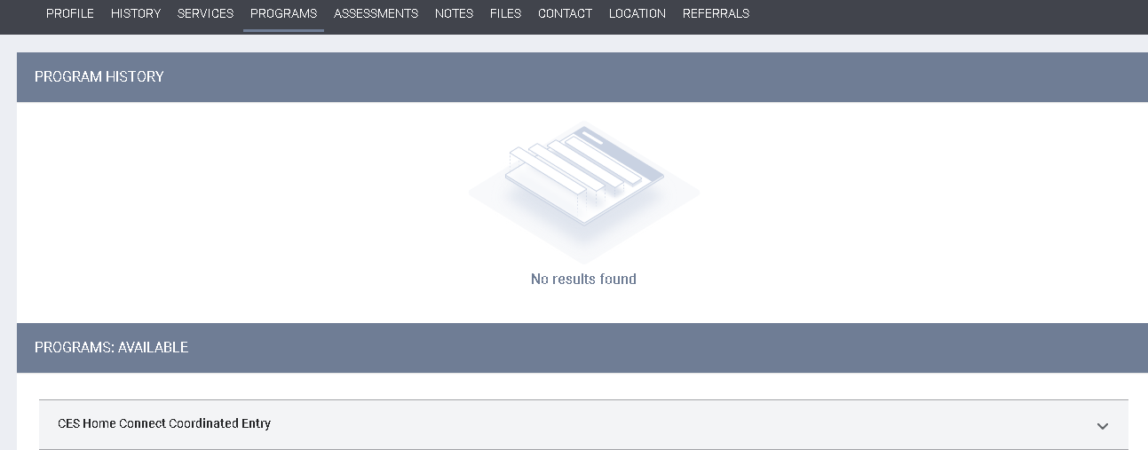
Select the drop down arrow to the right of “CES Home Connect Coordinated Entry”
You will now see the Enroll button under the CES Home Connect Coordinated Entry
Select Enroll to begin enrolling your client
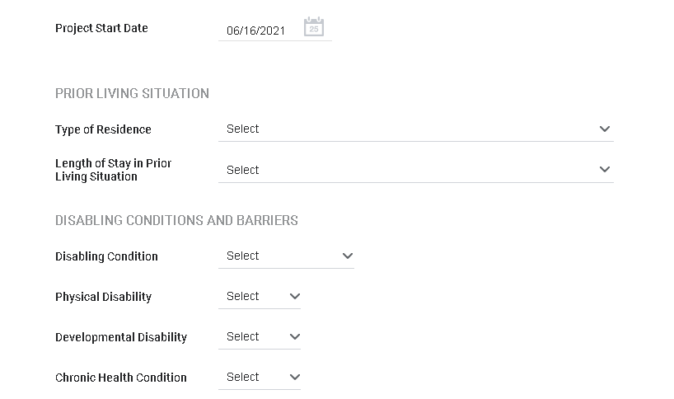
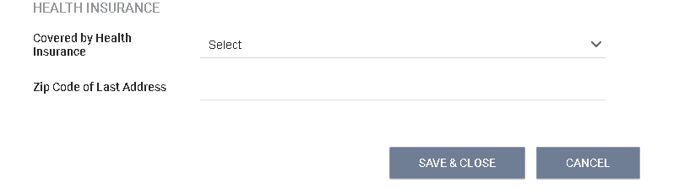
Select the Save & Close when you have entered all of the information
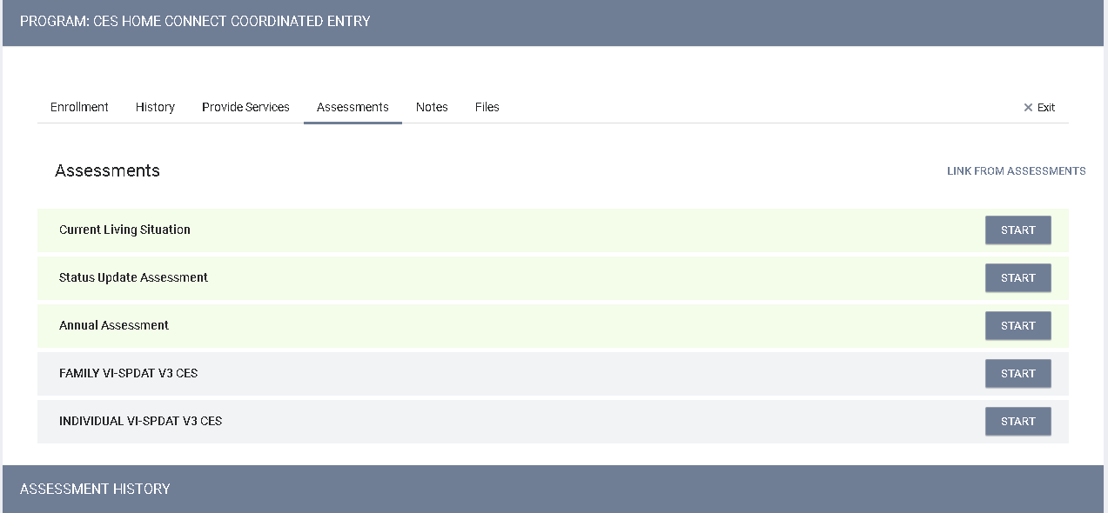
Once you have completed the enrollment of your client into CES Home Connect Coordinated Entry program, you will now have the ability to create assessments including VISPDATs.
To access the assessment screen, select the “Assessments” tab at the top menu shown in the screen shot above to begin

